The Diagnostic Value of Lung Ultrasound and Serum Level of Brain Natriuretic Peptide in Asymptomatic Pulmonary Congestion in Pediatric Hemodialysis Patients

Soha Abdel Hady Ibrahiem , Omima Mohammed Abdel Haie, Eman Ramadan Abdel Gawad, Rehab Elsaied Elsawy,Osama Mohammady Abd-Alkhalik, Heba Rasmy Abdelbaset, Eman Abdelbaset Mohamed

Departments of pediatrics, pulmonology and clinical pathology, Faculty of Medicine –Benha University, Egypt
*Corresponding author: Osama Mohammady Abd-Alkhalik, Mobile (+20)01009223659, E-Mail:osamamohamedy11@gmail.com

Abstract:
Background: Minimizing volume overload by optimizing the target dry weight (DW) in hemodialysis (HD) patients depending on clinical evaluation lack accuracy as signs of hypervolemia are observed only when over hydration is significant. Objective: To evaluate the diagnostic accuracy of serum level of brain natriuretic peptide (BNP) and it’s correlation with lung ultrasound (LUS) in detecting the presence of asymptomatic pulmonary congestion as a sign of residual volume overload in HD patient. Patients and Methods: A Prospective observational study was conducted on 20 HD patients with asymptomatic pulmonary manifestation who underwent LUS and BNP leveling before and after HD session, LUS was considered a positive when B-line score (BLS) >10.
Volume load parameters were also evaluated before and after HD.
Results: the reduction in mean BNP after HD session was significant as BNP levels reduced from (219.5±67.802) pg/ml to (116.75±50.772) pg/ml, with significant positive correlation between post dialysis BNP and BLS (p< 0.001, r 0.914).
Conclusion: A number of patients who were clinically euvolemic with no clinical parameters of overhydration at the end of HD session and believed at target DW demonstrated lung congestion at LUS. This suggest that patients at their supposed target DW may still have a residual volume overload that can be intercepted by LUS assessment and when LUS is not available, BNP leveling may be of some help.
Keywords: Pulmonary congestion, Lung ultrasound (LUS), Brain natriuretic peptide (BNP), Hemodialysis (HD), Dry weight (DW).

1. Introduction:
DW is a volumetric state without hypovolemia or hypervolemia. Chronic hypovolemia and hypervolemia due to incorrect estimation of DW can lead to chronic dehydration or long-term cardiovascular complications so, an accurate estimation of extravascular lung water is a primary approach to avoid this complications (1).
A number of patients who were clinically euvolemic and believed at target DW demonstrated lung congestion at LUS in the absence of oedema, dyspnoea, over hydration as assessed by bioimpedance analysis (BIA) or impaired left ventricular function (2).
LUS can evaluate the presence of pulmonary microcirculation congestion that is a frequent occurrence in HD patients, but often symptomless and not easily detectable (3). The increase in the pulmonary extravascular volume results in an air-water interface that induces an echo perceptible artefact known as B line and its detection allow to calculate a BLS which is used to quantify pulmonary congestion (4).
Also BNP serum levels may be useful as marker of over hydration; its concentration may be affected by multiple factors but it may be assumed as a marker of myocardial cell distension in response to circulating volume overload (5).
The aim of this study was to evaluate the role of BNP leveling in detecting the presence of asymptomatic pulmonary congestion in maintenance HD patients without clinical signs of over hydration. Also the relationship between BLS at LUS and BNP serum level was examined.

2. Subjects and Methods

This prospective observational study was carried out from July 2021 to January 2023 , in the pediatric nephrology unit of the Benha University hospital. The study was approved by the Local Ethical Committee of the Medical Faculty of Benha University, and written informed consent was obtained from the parents.
20 chronic hemodialysis children 3-18 years of both sex on thrice weekly schedule on HD unit for at least 6 months with clinical stability for at least 3 months with asymptomatic pulmonary manifestation.
Exclusion criteria:
- Patients with unstable clinical conditions.
- Patients with current infections.
- Patients with volume or pressure overload due to other causes than fluid overload as left ventricular dysfunction with EF< 50%, cardiac anomalies, pulmonary hypertension, clinical evident heart failure.
- In line with previous study carried out by (6), patients suffering from conditions where B lines may represent underlying pathology and confound the assessment of fluid overload as: Co-existing lung fibrosis, Atelectasis, Lymphangitis, Interstitial lung disease, cardiac failure and acute respiratory distress syndrome.
Patients were dialyzed on Fresenius 4008B and 5008s dialysis machine (Bad Homburg, Germany) at blood flow rate = 2.5 × weight (kg) + 100 ml/min, using polysulfone hollow fiber dialyzers suitable for the surface area of the patients (Fresenius F3 = 0.4 m2 , F4 = 0.7 m2 , F5 = 1.0 m2 , and F6 = 1.2 m2 ). Bicarbonate dialysis solutions were used.
All patients were subjected to the following:
Full history taking: including age, sex, residence, causes of CKD, duration of dialysis, and use of anti-hypertensive drug.
Clinical examination: including vital signs, anthropometric measurements and urine output.
Systemic examination including chest, heart, abdominal, and neurological examination.
The hydration status of the patients was evaluated by performing predialysis and postdialysis measurements: including clinical parameters of fluid overlaoad (dyspnea at rest, orbital edema, weight gain, hypertension and chest crepitation), interdialytic weight gain (IDWG), post dialysis weight, dry weight and both systolic blood pressure (SBP) and diastolic blood pressure (DBP), hypertension is defined as blood pressure greater than the 95th percentile for age, height, and sex according to pediatrics’ guidelines.

Laboratory investigations: routine investigations including complete blood count, , blood urea, serum creatinine , Na , K , Ca , Ph , PTH , .
Specific investigations: serum BNP levels with enzyme-linked immunosorbent assay (ELISA) were withdrawn 15 minutes before and 15 minutes after HD session.
ECHO for exclusion criteria.
LUS: LUS measurements were performed 15 minutes before and after the HD session with the available sonography equipment (GE LOGIQ V5 pro series ultrasound machine with linear probe 3-5 HZ). Patients were in supine position during the examination. Twenty-eight different lung windows were scanned in the midaxillary, anterior axillary, midclavicular and parasternal spaces of the right and left hemithoraces, from the second to the fourth (on the left) and to the fifth (on the right) intercostal spaces (7). According (8) The B-line sign was defined as an echogenic artifact with a narrow origin on the pleural line, deepening to the inferior border of the screen and coherent with respiratory movements. The total number of B-lines (BLS) was the sum of the artifacts recorded in the 28 sectors that were explored. Assuming a BLS cut-off value of 10, LUS examinations were considered as negative for pulmonary congestion when BLS ≤ 10 (LUS-) and positive for pulmonary congestion when BLS > 10 (LUS+) (6).
Statistical Analysis
Data were analyzed using appropriate 2-sided tests at 0.05 level of significance using SPSS V.28 software. Categorical data were presented as number and percentages while quantitative data were expressed as mean ±standard. The diagnostic accuracy of BNP for identifying post-dialytic pulmonary congestion was assessed using sensitivity, specificity, positive predictie value (PPV), negative predictive value (NPV), and accuracy. The receiver operating characteristic (ROC) curve was used to the test significance of the diagnostic accuracy using sensitivity versus 1- specificity. The area under the ROC curve is significant when it differs from the area of change which is 0.5.
3. Results
3.1 patient’s data:
20 patients were enrolled, 12 patients are male, median age was 14.6 years, all receive maintenance 3 HD sessions weekly for 3-4 hours with the main duration of HD 33±43.7 months , all growth parameters were decreased according to age and sex.
The most common cause of ESRD among studied patients was obstructive uropathy (8) followed by unknown etiology (5).
13 patients are normotensive and reached dry weight, 14 patient had normal Echo finding, the others (6) patients had left ventricular hypertrophy(LVH), the difference between patients with normal Echo finding and those with LVH in SPB, DPB, BLS and serum BNP were not significant.

3-2 volume load parameters measured before and after dialysis:
Table 1. Volume load parameters before and after dialysis
Before – after dialysis | Mean | SD | Diff. | Corr. (r) | p-valueǂ | t-test | p-value¥
weight before (kg) | 34.495 | 9.428 | 1.6 | 0.997 | <0.001 | 9.343 | <0.001
Weight after (kg) | 32.89 | 9.097
Systolic pressure before (mmHg) | 110.75 | 21.106 | 14.8 | 0.966 | <0.001 | 11.513 | <0.001
Systolic pressure after (mmHg) | 96 | 18.61
Diastolic pressure before (mmHg) | 70.75 | 14.714 | 13.3 | 0.935 | <0.001 | 10.878 | <0.001
Diastolic pressure after (mmHg) | 57.5 | 15.347
The measurements before dialysis indicates increase in volume overload while the differences between the predialysis and postdialysis values showed that hemodialysis decreased volume overload status and values among all the measured variables were significant as the mean decrease in weight, SBP and DBP were significant (p<0.001) with t-test (9.343, 11.513, 10.878), respectively.
3.3 change in both BLS and BNP with dialysis:
Table 2. Subgroup analysis of BNP and B line score by dry weight
Indicator |  | Dry weight (n=15) |  | p-value¥ | Non-dry weight (n=5) |  | p-value | Overall p-valueǂ
 |  | Mean | SD |  | Mean | SD
B line score | Before | 12.7 | 3.8 | <0.001* | 39.3 | 10.4 | 0.002* | <0.001*
 | After | 4.9 | 2.1 |  | 22.7 | 8.96
BNP (pg/ml) | Before | 184.6 | 51.7 | <0.001* | 284.3 | 40.9 | 0.008* | 0.478
 | After | 90.1 | 23.9 |  | 166.3 | 51.14
The reduction in both mean B-line score and mean BNP after dialysis session was significant among dry-weight patients (p < 0.001) and among non-dry weight patients (p = 0.002 and 0.008). Moreover, the difference between the two groups in the reduction of B-line score was significant, but in the reduction of BNP was not significant (p =0.478).
3.4 correlation between both BLS and BNP with each other and with other indices
Correlation of both predialytic BNP and BLS with other indices as IDWG, SPB and DBP were significantly positive, also correlation between both posdialysis BNP and BLS with difference between post dialysis weight and dry weight, SBP and DBP were significantly positive.As regard correlation between BNP and BLS, no significant correlation in predialysis setting (r 0.276, p 0.064), however the correlation in post dialysis setting was significantly positive (r 0.914, p< 0.001).

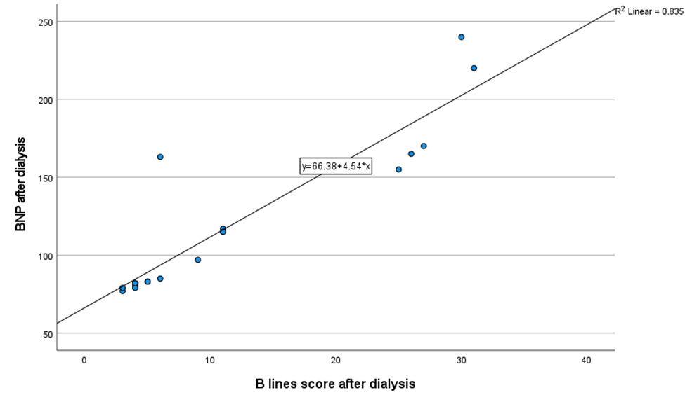
Figure 1. Scatter graph showing significant positive correlation between post-dialytic B-line score and post dialytic BNP.
3.4 cut off value of BNP for prediction of pulmonary congestion
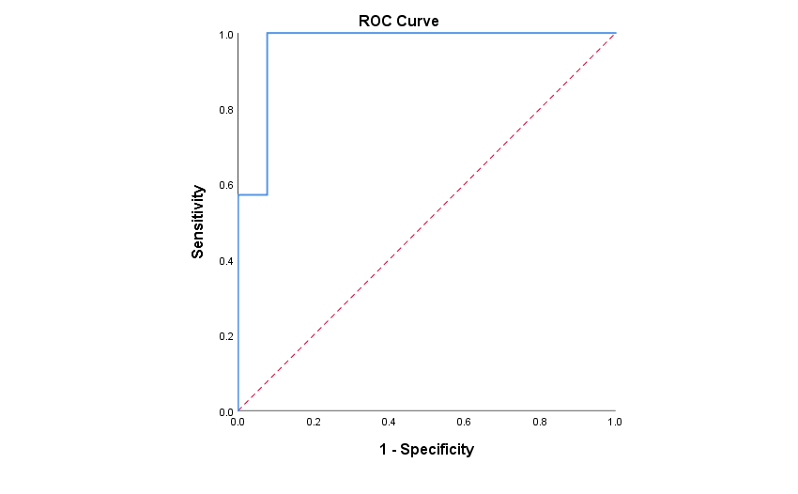
Figure 2. ROC curve of post-dialytic BNP for predicting pulmonary congestion.
The area under the curve was significantly higher than the area of the chance (0.967 vs. 0.5, p<0.001).The optimal BNP cut-off value for predicting pulmonary congestion resulted as 100 pg/ml (sensitivity 100, specificity 92.3, positive predictive value 87.5, negative predictive value 100 and accuracy 95).

All patients were subdivided into DW and non DW groups according to clinical parameters of volume overload, blood pressure and documented DW, also into pulmonary congestion (LUS+) and no pulmonary congestion according to BLS as BLS> 10 indicate pulmonary congestion.
Table 3. BNP levels in both dry and non-dry weight group according to pulmonary congestion finding (BLS> 10).
BNP (pg/ml) |  | No pulmonary congestion (LUS-)  (n = 13) |  | Pulmonary congestion (LUS+) (n =7) |  | p-value
BNP before, mean ± SD |  | 201.15 | 68.073 | 253.57 | 56.621 | 0.1
BNP After, mean ± SD |  | 88.69 | 22.845 | 168.86 | 47.39 | 0.003*
Dry weight, number (%) | Dry | 12 | 92.3 | 3 | 42.9 | 0.031*
 | Non | 1 | 7.7 | 4 | 57.1
This table show that 3 patients who reached target dry weight post dialysis had residual pulmonary congestion.
4. Discussion
Clinical examination is the classic tool for assessing hydration status at the patient’s bedside. However, it can be faulted in finer evaluation. There is currently neither a validated clinical score to assess hydration status in HD patients nor a gold standard to define the DW (9).
This study shows that the presence of pulmonary congestion as detected by lung ultrasound is quite prevalent in HD patients, even when no clinical signs of over hydration exist. In fact, 7 out of 20 patients, corresponding to 35%, presented with a BLS > 10 and BNP level >100 pg/ml at the end of the HD session, in the absence of edema, dyspnea or elevated blood pressure and 3 patients reached documented dry weight.
This result agrees with the data that emerged in other studies as study conducted by (2) which revealed that a number of patients who were clinically euvolemic and believed at target dry weight demonstrated lung congestion at LUS in the absence of edema, dyspnea, and over- hydration as assessed by BIA or impaired left ventricular function.
This suggests that patients at their supposed target weight may still have a residual volume overload that can be intercepted by LUS assessment and when LUS is not available BNP leveling may be of some help. Thus, it would be important that LUS have a key role in the clinical practice and become part of the nephrologist’s knowledge.
Echo was done for each patient by an expert pediatric cardiologist, 14 patient had normal Echo findings and 6 patients revealed LVH.
Our results showed no difference as regard BLS and BNP in both LVH and non LVH group. Similarly, (10) showed that there were no significant differences between patients with or without LVH and BNP levels before HD.
Also, (2) showed that no difference between LUS+ or LUS- patients considering cardiac pathology including LVH.
In contrast, (11) revealed that the patients with LVH were over hydrated on BIA measurement. They had significantly more B lines on lung US before HD and more than 3 times BNP levels before and after HD as compared with the patients without LVH. The patients with LVH also had higher systolic blood pressure before and after HD.
As regarding mean B-line scores, after the HD sessions, there was high significant decrease in the total number of B-lines. The mean total number of B-lines decreased from (22 ± 14.593) before dialysis to (11.1 ± 10.223) after dialysis. B-line scores were high significantly reduced after dialysis in the dry weight group (p < 0.001) and non-dry-weight group (p < 0.001). Before dialysis, the mean B-line scores of the dry-weight group (12.7 ± 3.8) were lower than those of the non-dry-weight group (39.3 ± 10.4). However after dialysis, the mean B-line scores of the dry-weight group (4.9± 2.1) were lower than those of the non-dry-weight group (22.7 ± 8.96) and the difference between the two groups was statistically significant (p < 0.001).
These results matched with (6) as in dry weight group, mean B-line scores fell from 23.5 before hemodialysis to 8.5 post-hemodialysis. While in non-dry weight group, mean B-line scores fell from 56.5 before hemodialysis to 32 post-hemodialysis.
In addition, lung ultrasound is suggested to be a measure of dry weight. The dry weight of children increases with growth, but B-line scores are not affected. The number of B-lines in the dry weight state is helpful for assessing a child’s volume state (6).
The use of cardiac biomarkers as BNP to evaluate the hydration status has also been suggested. These hormones are secreted by cardiomyocytes mainly in the heart ventricles in response to stretching caused by increased ventricular blood volume (12).
Over hydration is a major stimulator for Natriuretic peptides release. Some authors claim that it is not clear whether these biomarkers reflect fluid status or underlying structural organ damage (13).
We observed a tendency of higher BNP values in in pre dialysis than post dialysis as the mean BNP before dialysis was 219.5 ± 67.802 and after dialysis 116.75 ± 50.772. BNP levels were high significantly reduced after dialysis in the dry weight group (p < 0.001) and non-dry-weight group (p < 0.001). Before dialysis, the mean BNP levels of the dry-weight group (184.6 ± 51.7) were lower than those of the non-dry-weight group (284.3 ± 40.9). However after dialysis, the mean BNP levels of the dry-weight group (90.1± 23.9) were lower than those of the non-dry-weight group (166.3 ± 51.14) and the difference between the two groups was statistically significant (p < 0.001).
Our results revealed that BNP serum levels were higher in the case of LUS+ than in LUS- findings. BNP resulted 88.69 ± 22.845 pg/ ml for LUS- patients and 168.86 ± 47.39 pg/ml for LUS+ patients after dialysis. Similarly, (2) showed that the distribution of the BNP values for LUS- patients at 25th percentile was 74.2 pg/ ml, and at 75th percentile was 137 pg/ml while for LUS+ patients BNP levels at 25th percentile was 180 pg/ml, and at 75th percentile was 909 pg/ml.
The ROC curve of BNP serum levels as predictor of pulmonary congestion is shown in our results. The area under the curve was 0.967. The optimal BNP cut-off value for predicting pulmonary congestion resulted as 100 pg/ml (sensitivity 100, specificity 92.3, positive predictive value 87.5, and negative predictive value 100 with accuracy 95).
This suggests that BNP levels may be a valid surrogate which is able to suggest the presence of pulmonary congestion when LUS in not available (2).
In our study, BLS showed a positive correlation with BNP values in post dialysis (r= 0.914, p < 0.001) with no significant correlation in predialysis (r= 0.276, p= 0.064).
The same findings were shown by (2) and (14) that revealed that a positive association between BNP and BLS only when BNP was determined post-HD session, and not with pre-HD BNP levels. Instead, (15) showed no significant relationship between BLS and BNP values both pre and post dialysis.
The systematic application of LUS in HD patients, even when cardiac function is not impaired, may represent a useful method for the monitoring of dialysis population in the clinical practice. In addition, benefits for patients are represented by the safety of the method (in comparison with chest X ray or CT scan), the repeatability, the easy bed-side performance, and the clinical relevance of information that can give (2).
Unfortunately, a number of barriers exist preventing a widespread implementation of LUS procedure in daily clinical practice. Namely, the availability of sonography, the training and expertise of the operator, the need of a longer stay of the patients in the hospital. The chance of LUS examination at bedside and during or immediately after the end of the dialysis section is a possible way to increase its applicability. As a whole, the implementation of LUS assessment may be a useful a safe strategy for the fluid status monitoring of HD patients.
Our study open minded for application of LUS and serum BNP in optimizing dry weight , but we need for more studies with large sample size and serial LUS and BNP leveling.
5. Conclusions
Our data showed that a number of patients who were clinically euvolemic at the end of HD session and believed at target dry weight demonstrated lung congestion at LUS in absence of clinical evidence of overhydration as dyspnea, edema and elevated blood pressure. This suggests that patients at their supposed target weight may still have a residual volume overload that can be intercepted by LUS assessment. BNP serum level > 100 pg/ml resulted predictive of pulmonary congestion at LUS in which BLS > 10. This suggest that BNP level can be used when LUS is not available.

6. References
1- Hecking M, Rayner H and Wabel P (2015): what are the consequences of volume expansion in chronic dialysis patients: defining and measuring fluid overload in hemodialysis patients. Semin Dial; 28: 242-247.

2- Giannese D, Puntoni A, Cupisti, A, et al., (2021): Lung ultrasound and BNP to detect hidden pulmonary congestion in euvolemic hemodialysis patients: a single center experience. BMC nephrology; 22(1): 1-8.

3- Torino C, Gargani L, Sicari R, et al., (2016): The agreement between auscultation and lung ultrasound in hemodialysis patients: the LUST study. Clin J Am Soc Nephrol; 11: 2005–2011

4- Volpicelli G, Elbarbary M, Blaivas M, et al., (2012): International Liaison Committee on Lung Ultrasound (ILC-LUS) for International Consensus Conference on Lung Ultrasound (ICC-LUS): International evidence-based recommendations for point-of-care lung ultrasound. Intensive Care Med; 38:577–91.

5- Puntoni A, Giannese D, Varricchio E, et al., (2020): Different methods to manage dry weight in hemodialysis patients. G Ital Nefrol; 37:1.
6- Fu Q, Chen Z, Fan J, et al., (2021): Lung ultrasound methods for assessing fluid volume change and monitoring dry weight in pediatric hemodialysis patients. Pediatric Nephrology; 36(4): 969-976.

7- Allinovi M, Saleem M, Romagnani P, et al., (2017): Lung ultrasound: a novel technique for detecting fluid overload in children on dialysis. Nephrology Dialysis Transplantation; 32(3): 541-547.

8- Yontem A, Cagli C, Yildizdas D, et al., (2021): Bedside sonographic assessments for predicting predialysis fluid overload in children with endstage kidney disease. European Journal of Pediatrics: 1-10.

9- Bobot M, Zieleskiewicz L, Jourde-Chiche, N, et al., (2019): Diagnostic performance of pulmonary ultrasonography and a clinical score for the evaluation of hydration status in hemodialysis patients.
10- Mouche A, Parmentier C, Fendri F, et al., (2023): Benefits of BNP/NT-proBNP serum level evaluation for dry weight adjustment in pediatric hemodialysis patients. Pediatric Nephrology; 38(3): 811-818.
11- Vaičiūnienė R, Štramaitytė I, Bura A, et al., (2017): Associations between Left Ventricular Hypertrophy and Hydration Status in Hemodialysis Patients. Medicina (Kaunas); 53: 47-51.‏
12- Wang Y, Cao X, Yu J, et al., (2021): Association of N-terminal pro-brain natriuretic peptide with volume status and cardiac function in hemodialysis patients. Front Cardiovasc Med; 8:646402.
13- Davies S J and Davenport A (2014): The role of bioimpedance and biomarkers in helping to aid clinical decision-making of volume assessments in dialysis patients. Kidney international; 86(3): 489-496.

14- Donadio C, Bozzoli L, Colombini E, et al., (2015): Effective and timely evaluation of pulmonary congestion: qualitative comparison between lung ultrasound and thoracic bioelectrical impedance in maintenance hemodialysis patients. Medicine; 94: 473.

15- Basso F, Milan Manani S, Cruz DN, et al., (2013): Comparison and reproducibility of techniques for fluid status assessment in chronic hemodialysis patients. Cardio renal Med; 3:104–112.

